Day 1

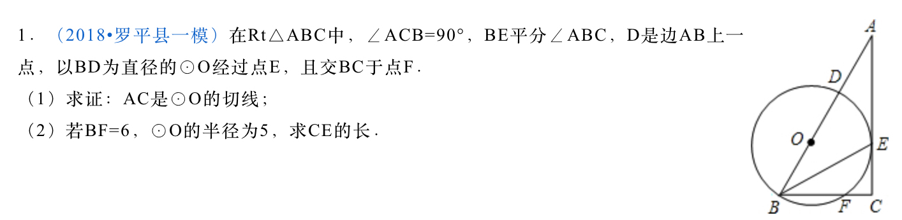

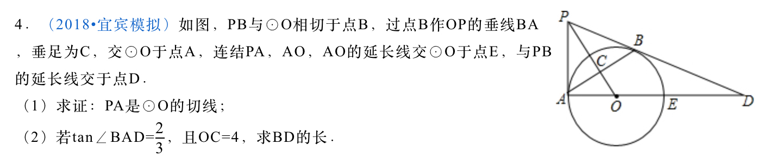

Day 2

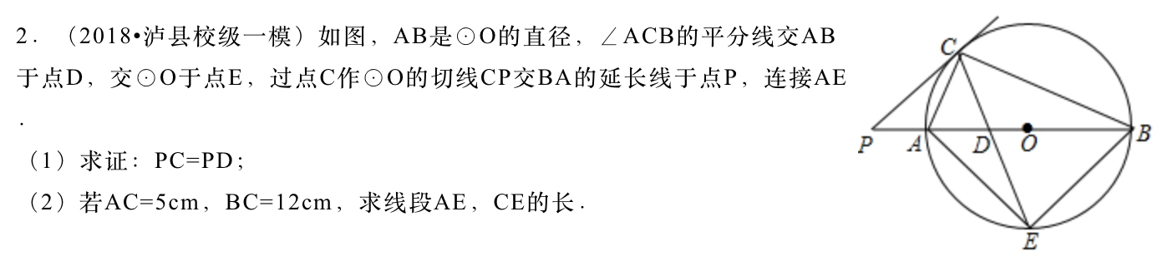

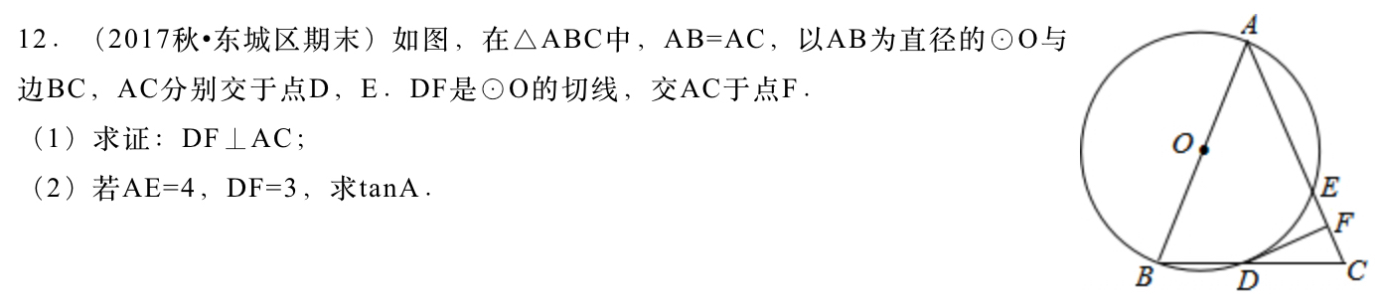

Day 3

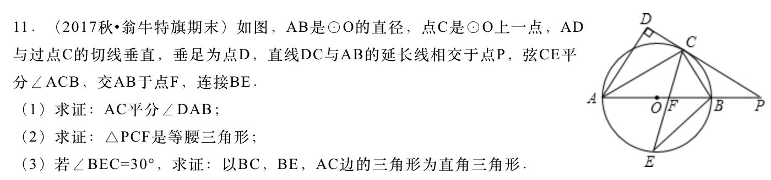

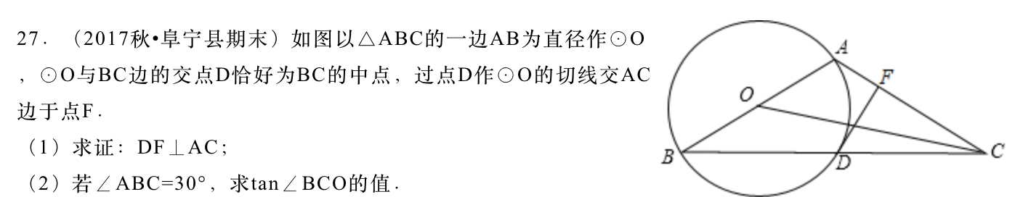

Day 4

